EDUCATIONAL SOFTWARE FOR INTERACTIVE TRAINING OF STUDENTS ON

THE THEME

“MUTUAL INTERSECTING OF PYRAMIDS AND PRISMS IN AXONOMETRY”

Samet Karaibryamov*, Bistra Tsareva, Boyan Zlatanov*
* Authors are partially supported by Plovdiv University “Paisii Hilendarski” NPD Project NI11–FMI-004.

Abstract: This work acquaints with the program Sam for interactive computer training of students on the theme "Mutual intersecting of pyramids and prisms in axonometry”. The program containing three modules – teacher, student and autopilot – allows for briefest time to teach and study the whole variety of the tasks on this theme.
A classification of the pierce points of the surrounding edges of the one polyhedron with the other one, based on the mutual position of their auxiliary planes, is made.
The solutions of the tasks can be traced in each of the popular axonometric projection (cabinet projection, cavalier perspective, military perspective, increased orthogonal dimetry, increased orthogonal isometry) in their significant stages as well as in each step.
Each stage of the solution is accompanied by commentary. The student can manipulate any object of the drawing or can apply on the whole drawing rotation, translation, expansion, shrink, zoom, etc.
The student can watch on all sides the rotating 3D image of the composition of the two intersecting polyhedrons and separate the rotating 3D image of their common part.
The combination of traditional methods of training in descriptive geometry using the program Sam and the classification of the pierce points enable for a thorough, creative and self study of the students. They are instruments through which the students can not only learn in depth material for a short time, but they can prepare creative course projects such as: improvisations on a task or a selection of tasks from known sources and creating original tasks on a given topic.
The program also allows to create dynamic geometric drawings.
Key words: educational software, interactive computer training, mutual intersecting, pyramid, prism, descriptive geometry, axonometry.
2010 Mathematics Subject Classification: 97R10, 97R20

1. Introduction.
Work [1] introduces a program for interactive computer training of students on the theme "Mutual intersecting of pyramids in axonometry." It is a part of a project to train students on the theme "Mutual intersection of bodies". The program receives the name Sam just after completing the first stage of its development (Mutual intersection of prisms and pyramids in axonometry). That is why in [1] the program has not been named. In [1] the basic objects apex line and surrounding edge were called peak line and roundabout edge, respectively.
Let’s recall that the program Sam allows to follow the manual solution of the tasks, where the method of the auxiliary planes is used [2], [3], [4], [5].
The theme "Mutual intersecting of pyramids and prisms in axonometry” is not only large in content, but the process of its teaching as well as the process of its learning from the students require a lot of technological time due to the specifics in solving of the tasks. The program Sam written in C# using the .NET framework 4 [6], [7] and its application in training solves the above problems successfully [8, part II, section II]. It offers to the user the solution of the task in each of five popular axonometric projection. He has the opportunity to examine them, to make his choice and to follow there the detailed steps in the solution and comments about them.
Note that the program Sam provides wider applications in the teaching of geometry, such as creating of dynamic geometric drawings, associated mainly with the application of projective methods in solving of problems. Sharing the view, expressed in [9], that “the software for the educational use should be restricted to only the bare necessities”, we created the software Sam for interactive training of the students on a syntetic geometry in a dynamic environment [8], [10]. Its unique function –swap of finite and infinite points (activated by the button “select”) optimizes significantly the drawing work [11].

2. Preliminary.

When two polyhedrons intersect some parts of them may not participate in the intersection. They contain some surrounding edges that have no common points with the other polyhedron. These parts are called isolated [2], [3].
Let us remember that all auxiliary planes used in the mutual intersecting of two polyhedrons form a bundle of planes through the apex line which is a finite straight line in the cases of two pyramids or a pyramid and a prism and an infinite straight line in the case of two prisms. The determination of isolated parts on the polyhedrons, which will be intersected, is done with the help of the contour auxiliary planes or called also tangent auxiliary planes through the apex line, so that within the dihedral angle, defined by them, all other auxiliary planes are situated. This means an analogous situation of the traces of the tangent auxiliary planes on the drawing plane. So the traces of the tangent auxiliary planes for each polyhedron can cut off from the base of the other polyhedron isolated parts. The steps of those surrounding edges which do not puncture the other polyhedron are located there. Since the bases of the polyhedrons examined by us are convex, the number of isolated parts may be 2, 1, 0.

The situation of the isolated parts on both mutual intersecting polyhedra and its influence on the type of the intersection

1. Two isolated parts. There are two options for the situation of the two isolated parts.
1.1 There is exactly one isolated part on each polyhedron. This means that there are surrounding edges on each polyhedron, that don't pierce the other polyhedron. Now the intersection line is one closed spatial broken line.
1.2 The two isolated parts are located on one of the polyhedra. This means that surrounding edges of exactly one of both polyhedra do not pierce the other one. Now the intersection line contains exactly two spatial polygons.

2. One isolated part. This is possible when one pair of the tangent auxiliary planes coincide. Therefore, two surrounding edges not only intersect, but their common auxiliary plane is simultaneously tangent to both polyhedrons. The intersection point of these two special surrounding edges can be called a tangency point for both polyhedrons.
Now the intersection line can be treated as a closed broken line, which passes twice through the tangency point or as two closed broken lines with a common point – the tangency point.

3. No isolated parts. This is possible when the two pairs of the tangent auxiliary planes coincide. Therefore, both polyhedra have two tangency points.
Now the intersection line contains several separate components with two general points – points of tangency. It can be treated either as a closed broken line, which passes several times through each of the tangent points, or as several spatial polygons, each of which has vertices at the tangency points.
Because of the convexity of the polyhedrons the points of tangency can not be more than two when their number is a finite numeral. The case of existence of countless tangency points is seen in §1.
When looking for the pierce points of the surrounding edges of the one polyhedron with the other one the program includes the following four options, described in [1]:
P1) The surrounding edge of the one polyhedron intersects the other one in two interior points of two different surrounding walls of the other polyhedron;
P2) The surrounding edge of the one polyhedron intersects the other one in two points, one of which lies in the interior of a surrounding wall and the other point is on a surrounding edge of the other polyhedron;
P3) The surrounding edge of the one polyhedron has exactly one common point with the other polyhedron which is the intersection point of the considered surrounding edge with a surrounding edge of the other polyhedron;
P4) The surrounding edge of the one polyhedron has no common points with the other polyhedron.

3. Mutual intersecting of convex polyhedrons

Work [1] contains a theoretical justification of the algorithm for finding the pierce points of a surrounding edge of one of the polyhedra with the other polyhedron.
Up to now the program Sam solves tasks when the bases of the polyhedrons do not participate in the intersection and where the vertices of the polyhedrons are known, i.e. their coordinates are given. Let us note that setting the coordinates by arbitrary decimal numbers facilitates the author's work in composing the tasks involving the whole range of diversity of the pierce points described by our classification.
The program contains three modules called student, teacher and autopilot.
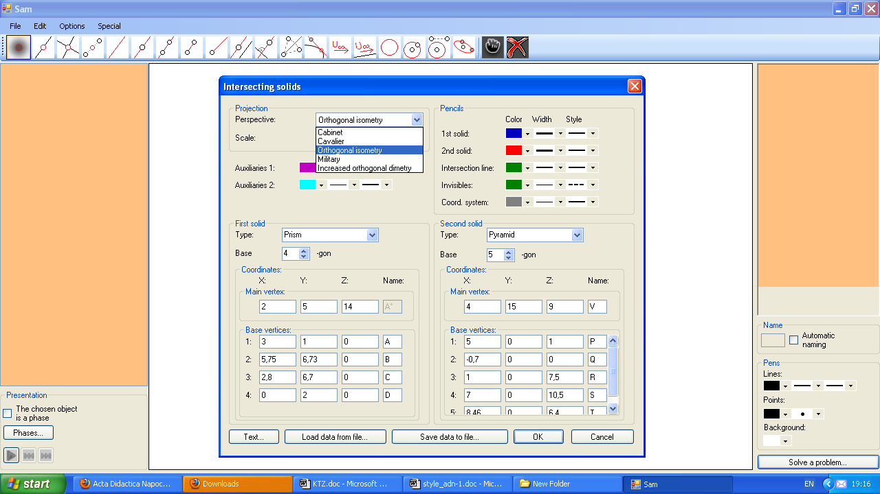
Autopilot module offers the complete solution of the task. The input parameters for this module are: (Figure 1.) the choice of projection, scale; the information about the type of polyhedra (prism or pyramid), the number of the angles of each base, the coordinates of their vertices. The next input parameters concern the design of the drawing: color, width, style of the lines: Then it is enough to click OK. The solution includes the final sketch, a list of stages with a brief comment for the significant ones and a sequence of all steps in the solution.
Figure 1. Input parameters
The stages in the solution of any task are: displaying of the bodies, constructing of the apex line and its steps, constructing the pierce points of all surrounding edges, developing the pierce scheme, correcting the visibility of the edges conformed on the mutual intersecting of the bodies.
Let denote that during the presentation all construc-tions, not participating in the

current and subsequent stages, are hidden.
At the end the student can watch on all sides the rotating perspective image of the composition of the two intersecting polyhedrons and separate the rotating perspective image of their common part.
Teacher module is designed for teachers and trainers who know how to solve a problem and want to provide this solution to their students. So there are two main groups of the teacher’s functions:
a) to select or to compose by himself a set of tasks from this area, to sort and save them with an appropriate name in folders. Our program provides the fastest performance of this work;
b) to train students presenting the solutions of the tasks. The panel presentation is located in the lower left corner of the screen and directed by three buttons (start or stop, forward, backward).
The program allows:
1. the teacher:
1.1 to select solution in one of the five popular axonometric projections, which in his opinion is the best suited for the specific task;
1.2 to extend appropriately the comments of the solution, to add new stages and additional images, considering specificity of the task;
1.3 to mark a single object (point, straight line, ...) during the presentation to focus on it;
1.4 to hide (to make transparent) any of the lines of the drawing, to enable students to more easily track a specific sequence of operations;
1.5 to colour fragments in the drawing, again to facilitate the students’s tracking of the solution;
1.6 to move the drawing across the screen subjecting it to rotation, translation, expansion, shrink , zoom; There is a point on the axis z. Her movement changes the scale directly.
1.7 to print and copy solved tasks;
1.8 to open a new window on the screen to simultaneously monitor the drawing and the pierce scheme or the condition of the task. This allows for reasoned change of the coordinates of some points in order to obtain a new task with the predicted solution.
2. the student:
2.1 to train alone on the subject as follows the solutions of the tasks (drawings and comments) prepared by the teacher, using all the options listed in 1. Marking one object or a set of objects in the drawing automatically leads to the marking of their corresponding construction operations in the list of all constructions;
2.3 to be free to experiment on the drawing manipulating each of his subject separately or the whole drawing;
2.4 to compose new tasks and to monitor their solution;
2.5 to consult with the solution of the task by the program Sam, when he had tried on a sheet manually or on a computer screen to solve the problem and he has had difficulty in some stages.
The classes of lectures and seminars are not sufficient to range over the large variety of tasks in the subject "Mutual intersecting of pyramids and prisms in axonometry”. It arises from the following circumstances:
R.1. Type of polyhedrons.
R.1.1. Two pyramids; R.1.2. Pyramid and prism; R.1.3. Two prisms.
R.2. Location of the bases of the polyhedrons.
The mutual intersecting of bodies which bases lie in the coordinate planes of the spatial coordinate system, is included in the curriculum of all high schools, studying descriptive geometry. Take into account textbooks and teaching aids and without loss of generality we can consider cases when at least one of both polyhedrons has a base lying in μ (the horizontal coordinate plane). So following the main purpose of the program Sam to serve the students’ training on the theme "Mutual intersecting of two bodies”, we invested in the program 9 of 18 existing options for a disposal of the bases of both polyhedrons in coordinate planes for each of the cases R.1.1, R.1.2, R.1.3.
Let’s note that the remaining 9 cases also may be included without any difficulty in the subsequent expansion of the program because the algorithm has already been created. Furthermore, by rotation of the entire composition we can get an idea of it in a new location of both bases, changed in our own desire.
R.3. The number and the type of the pierce points on every surrounding edge of one polyhedron with the other one depends on the mutual position of the auxiliary plane of the concerned surrounding edge with the auxiliary planes of other surrounding edges. Our research led to the expansion of the described in [1] commonly encountered four cases and we have included another three cases:
P5) Both polyhedrons have a tangency point;
P6) Both polyhedrons have a tangency segment;
P7) Both polyhedrons have a tangency area.
As it is known two pierce points define a segment in the broken intersection line when they lie simultaneously in surrounding walls for both the polyhedrons.
Let's call the process of describing the intersection line of both intersecting polyhedrons developing the pierce scheme.
The algorithm embedded in the program Sam for finding the pierce points operates without problems for each of the above cases. Difficulties in developing the pierce scheme are being overcome whenever particular cases appear. We have tried to describe the diversity of pierce points, based on the mutual position of the auxiliary planes of the different surrounding edges and we reached to the following
Classification of the pierce points
C1). The auxiliary plane of a surrounding edge of the one polyhedron does not pass through any other surrounding edge. Then there are the following possibilities:
C1.1. The investigated surrounding edge doesn’t have a common point with the other polyhedron;
C1.2. The investigated surrounding edge pierces the other polyhedron in two interior points of two different surrounding walls.
C2). The auxiliary planes of two surrounding edges of different intersecting polyhedrons match. Then there are the following possibilities:
C2.1. The common auxiliary plane of the two surrounding edges is not tangent to any one of both polyhedra.
Now everyone of the surrounding edges has two pierce points: one common (their intersection point) and one in the interior of a surrounding wall of the other polyhedron. The total number of puncture points on both intersecting surrounding edges is three.
C2.2. The common auxiliary plane of the two surrounding edges is tangent exactly to one of both polyhedra. In this case, the two intersecting surrounding edges have two pierce points as one of them is common;
C3). The common auxiliary plane of two surrounding edges, belonging to different intersecting polyhedra, is simultaneously tangential to both polyhedrons, i.e. it coincides with the one pair of tangent auxiliary planes for both polyhedra.

We will say that two polyhedra have a tangency point when two of their tangent auxiliary planes coincide so that exactly two surrounding edges, belonging to different polyhedra lie there .

C4). The two pairs of tangent auxiliary planes for both intersecting polyhedra coincide. Now the polyhedra have two tangency points.
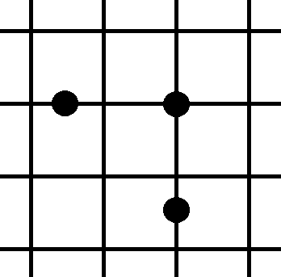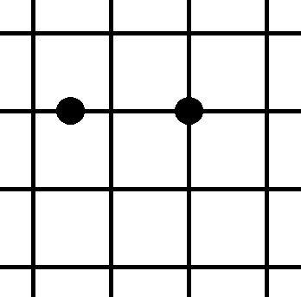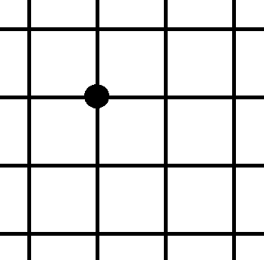
Figure 2. C2.1 Figure 3. C2.2 Figure 4. C3
C5). The auxiliary planes of two surrounding edges of one of the polyhedra coincide. Then there are the following possibilities:
C5.1. The common auxiliary plane of two surrounding edges of one of the intersecting polyhedra does not pass through a surrounding edge of the other one. Then each of both investigated surrounding edges is in the situation C1).
C5.2. The common auxiliary plane of two surrounding edges of one of the intersecting polyhedra passes through the surrounding edge of the other one, i.e. three surrounding edges have a common auxiliary plane.
Now there are two pairs formed from the three investigated surrounding edges that are in situation C2) or C3).
C5.2 U C2.
The total number of the pierce points is four and each edge has two pierce points located as follows: one in the interior of a surrounding wall and one on the already mentioned third edge of the other polyhedron.
Let’s remember that two surrounding edges, lying in one surrounding wall of the polyhedron, are called neighboring.
C5.2.1 Both surrounding edges of one of the polyhedra are not neighboring. Hence the common auxiliary plane is not tangent to any polyhedron. Then there is not a segment on the third surrounding edge in the intersection line.
C5.2.2 Both surrounding edges of one of the polyhedra are neighboring. Hence the common auxiliary plane is tangent only for this polyhedron. Then the segment on the third surrounding edge participates in the intersection line;
C5.2 U C3
C5.2.3 The common auxiliary plane for the three surrounding edges is tangent to both polyhedrons.
The pierce points are two and they are intersection points of the surrounding edges of the one polyhedron with the third surrounding edge which belongs to the other polyhedron.
Note that the extension P5) concerns this case.
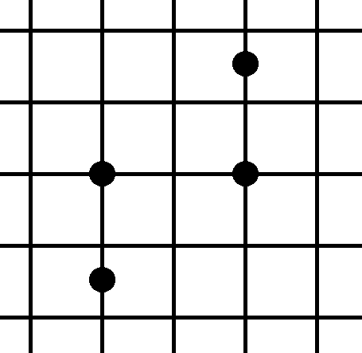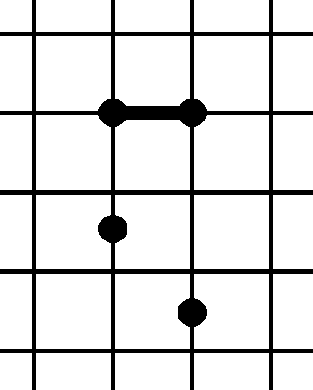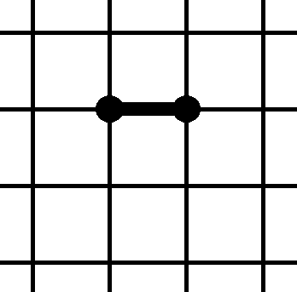
Figure 5. C5.2.1 Figure 6. C5.2.2 Figure 7. C5.2.3
We will say that two intersecting polyhedra have a tangency segment when two of their tangent auxiliary planes coincide so that exactly two neighboring surrounding edges for the one polyhedron and one surrounding edge for the other one lie there .

C6) The auxiliary planes of four surrounding edges (two from each polyhedron) match.
The pierce points are four, located two on each of these surrounding edges and none of them is in the interior of a surrounding wall. Now there are three options for both couples of surrounding edges :
C6.1. The surrounding edges in both couples are not neighboring. Now the broken intersection line does not contain segments belonging to any of these edges.
C6.2. The surrounding edges exactly in one of the couples are neighboring. Hence the common auxiliary plane is tangent for exactly one of both polyhedra.
Now the situation C5.2.2 appears twice and the broken intersection line contains two segments belonging to the surrounding edges which are not neighboring.
C6.3. The surrounding edges in both couples are neighboring. Hence the common auxiliary plane is simultaneously tangent for both polyhedra.
Then the four pierce points are vertices of one flat quadrilateral whose area is the common part of the surrounding walls where both pairs of
neighboring surrounding edges lie. This area joins the broken intersection line of both intersecting polyhedrons.

We will say that two intersecting polyhedrons have a tangency area when two of their tangent auxiliary planes coincide so that exactly two couples of neighboring surrounding edges for the two polyhedra lie there.
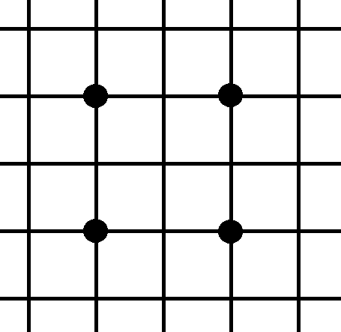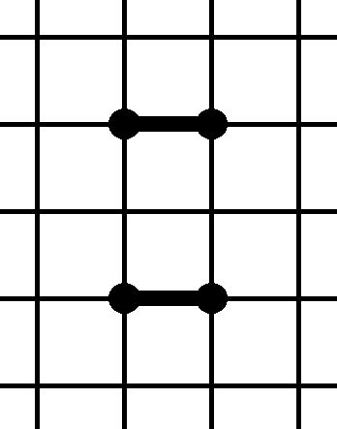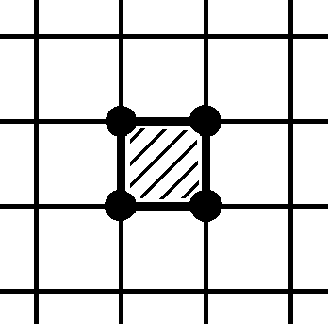
Figure 8. C6.1 Figure 9. C6.2 Figure 10. C6.3
This approach allowed us to crawl all options of an intersection when the bases do not participate, to inform the program for them and to prepare it to respond adequately.
Program and the classification of pierce points are instruments through which the students can not only learn in depth material for a short time, but they can prepare creative course projects such as:
Improvisations on a task. Different tasks are primary conditions determining the difficulty of improvisations. The primary condition and the richness of the improvisation will determine the assessment.
One selection of tasks from known sources and creating of original tasks on a given topic.

4. Mutual intersecting of two pyramids

Work [1] is devoted to the mutual intersecting of two pyramids and it was the first announcement of the program Sam. In its present form the program solves much larger class of tasks. That is why here we only offer a more interesting problem concerning cases C4) and C2.1.
Let us recall here that the apex line t passes through the apexes V and U, so that all the auxiliary planes belong to a bundle of planes with a carrier the finite straight line t.

Example 1. Represent the mutual intersection of the pyramids VABC [V (2, 0, 10), A (0, 4, 0), B (-4; 10, 0), C (-9; 6, 0)] and UPQR [ U (-7; 0, 10), P (2, 4, 0), Q (6, 8, 0), R (0, 10, 0)].
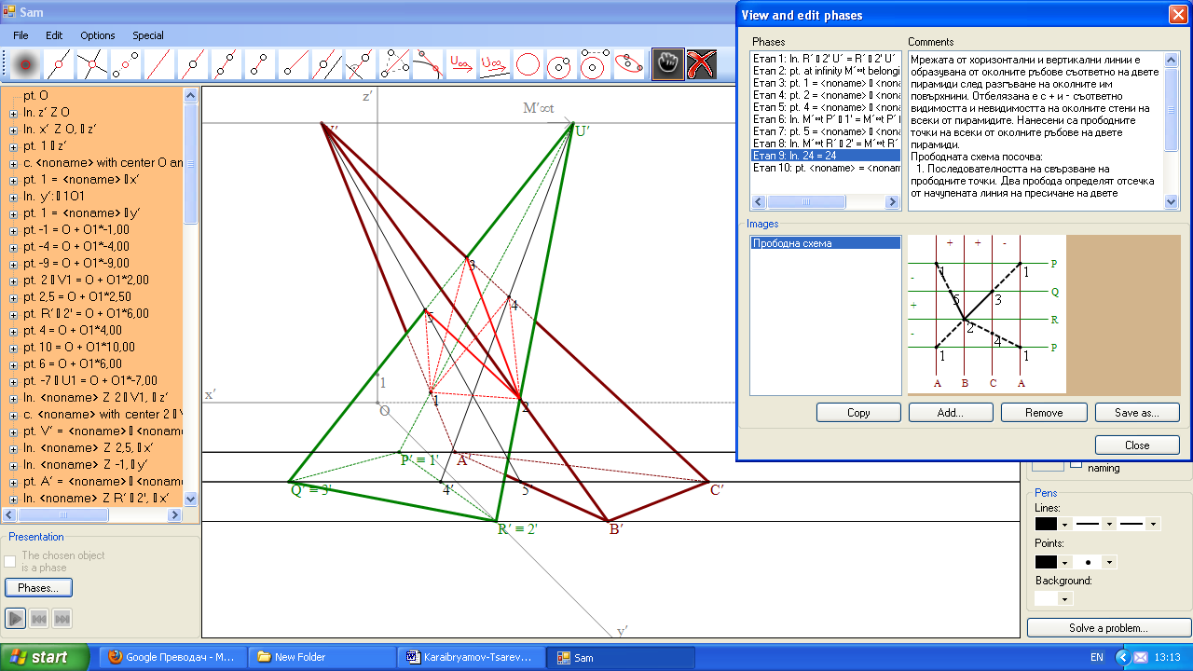
Bases of the two pyramids are in the first coordinate plane μ and the apex line t is parallel to the axis x, which means t is also parallel to μ. So the first step of the apex line t is infinite and the first traces of all the auxiliary planes are parallel to x. Both pyramids have two tangency points, named 1 and 2. Furthermore, the third couple of surrounding edges VC and UQ have a common auxiliary plane (the case C2.1). The intersection line contains three triangles with a common side joining the two tangency points: 123, 124, 125.
Figure 11. Example 1
The solution is presented in a cavalier perspective.

5. Mutual intersecting of a pyramid and a prism

Now the apex line t, passes through the apex of the pyramid and it is parallel to the surrounding edges of the prism. Depending on the location of the bases of both polyhedrons the program decides which steps of the apex line t it has to find in order to continue the solution of the task. As it is known the traces of all auxiliary planes pass through the steps of t

We will illustrate the operation of the program with the following task:

Example 2. Represent the mutual intersection of the pyramid VABC [V (6; 5; 12,5), A (8; 1; 0), B (0; 4.5; 0), C (3; 8; 0), D (7,5; 6; 0)] and the right prism PQRSP°Q°R°S° [P (6; 0; 1), Q (2; 0; 5,5), R (6; 0; 8), S (8; 0; 6)] with a height 11.
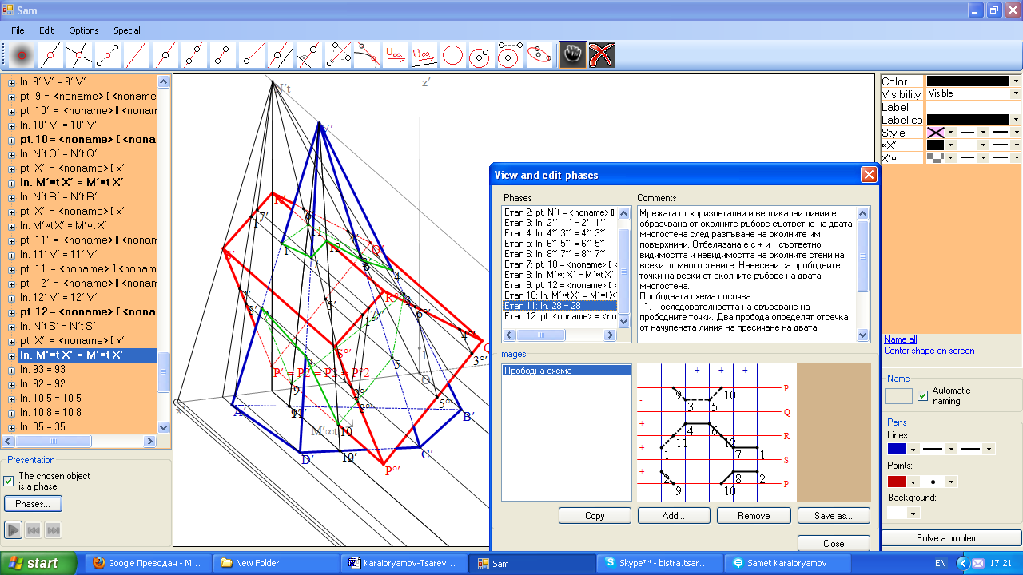
The first step of the apex line is an infinite point because the surrounding edges of the prism are parallel to axis y, which means they are parallel to µ. The second step of the apex line is a finite point. The task is standard and contains only pierce points of the type C1). Because
Figure 12. Example 2
there are two isolated parts on the base of the prism, the pyramid penetrates into the prism. The solution is presented in an increased orthogonal dimetry.

6. Mutual intersecting of two prisms

At mutual intersecting of two prisms the apex line t passes through the infinite points of the surrounding edges of both prisms. Therefore a plane which is parallel to the surrounding edges to both prisms is a representative of the infinite straight line t and all auxiliary planes are parallel to each other. So it is sufficient to display the tracks of the auxiliary plane of one of the surrounding edges. For this purpose we use: 1) the base vertex of the selected surrounding edge lying in a coordinate plane, because it coincides with its step; 2) the steps of the straight line passing through the other vertex of the selected surrounding edge and parallel to the surrounding edges of the other prism.
An essentially used fact is that the first and the second (third) traces for any plane intersect on the axis x (y). The traces of the other auxiliary planes are parallel to the same name traces of the already constructed auxiliary plane.
Our program considers the following two cases:

4.1 The surrounding edges of both prisms are not parallel to any coordinate plane.

4.2 The surrounding edges of at least one of the prisms are parallel to the i-th (i = 1,2,3) coordinate plane. Therefore, the i-th traces of the auxiliary planes are parallel to these surrounding edges. This makes unnecessarily the preliminary determination of the direction of the i-th trace of the auxiliary planes.
The right prisms with bases in the coordinate planes are a special case of 4.2. Here the directions of both used traces of the auxiliary planes are known. They are parallel to two of the coordinate axes, respectively. So in the drawing plane they are parallel to two of the axonometric axes, depending on where the bases of the prisms are situated.

Example 3. Represent the mutual intersection of the prisms ABCDEA°B°C°D°E° [A (6; 0; 0), B (2; 0; 0), C (1; 4; 0), D(3,5; 6; 0), (7; 6; 0), A° (9; 2; 15)] and
PQRSP°Q°R°S° [P (1; 0; 3), Q (-5; 0; 1), R (-2; 0; 6), S (0; 0; 7), P° (18; 10; 7)].
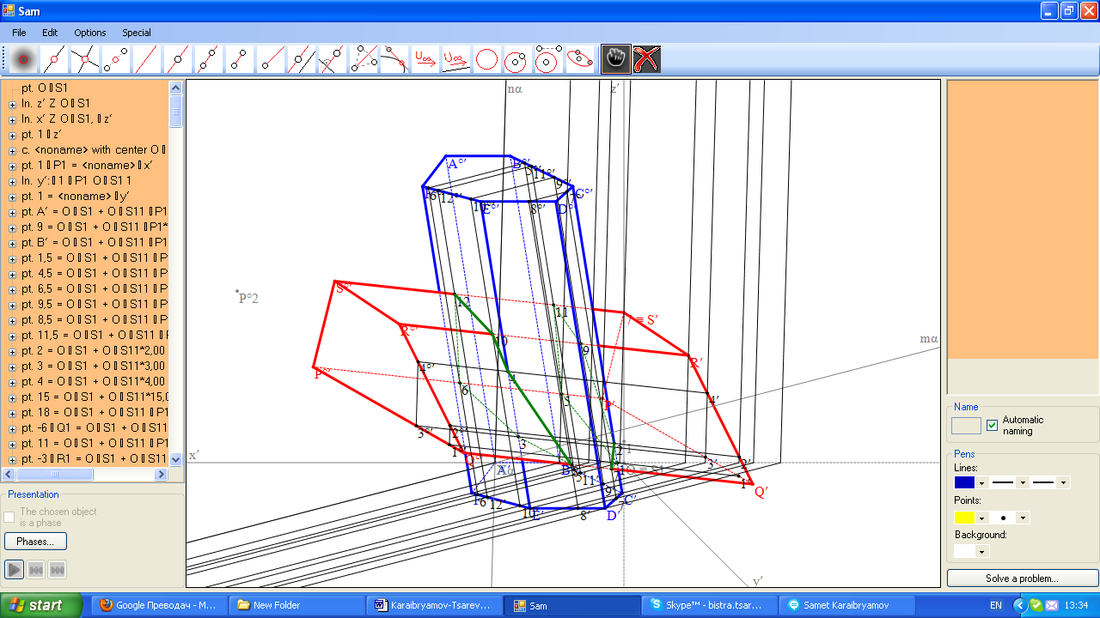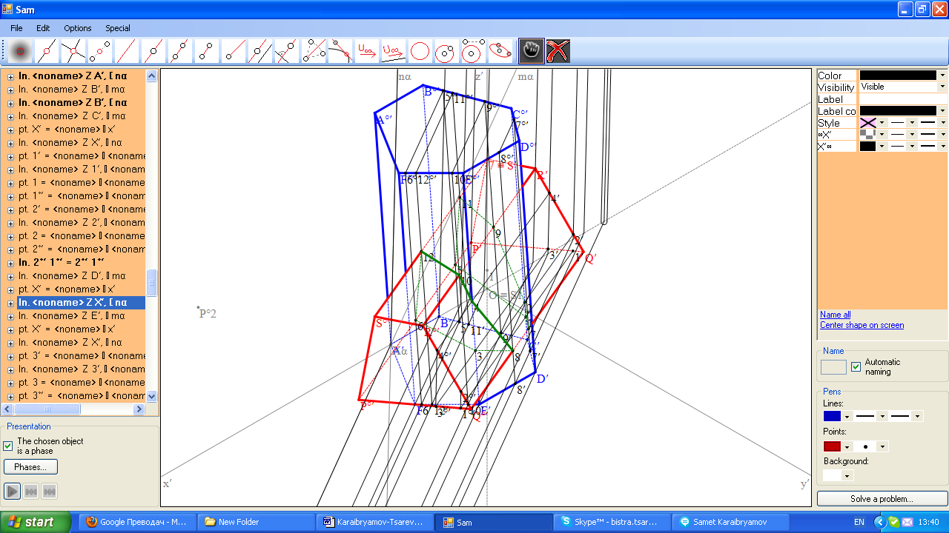
Figure 13.1 Figure 13.2 Example 3

This example illustrates the case 4.1. The solution is presented in cabinet projection (Figure 13.1) and in an increased orthogonal isometry (Figure 13.2) to show the influence of the choice of a projection on the view of the composition of both intersecting polyhedrons. In our opinion the instantly presentation of the task solution in any of the five popular axonometric projection is one important advantage of the program Sam.
Both the prisms are inclined. As it is evidenced from the drawings, this is a case of a penetration of the quadrangular prism in the hexagonal prism.
Example 4. Represent the mutual intersection of the right prisms ABCDEFA°B°C°D°E°F [A (3; 7,5; 4), B (5; 9; 0), C (9; 7,5; 0), D (9; 4,5; 0), E (5; 3; 0), F(3; 4,5; 0), A° (3; 7,5; 14)] and PQRSTKP°Q°R°S°T°K° [P (3; 0; 7,5), Q (5; 0; 9), R (9; 0; 7,5), S (9; 0; 4,5), T (5; 0; 3), K(3; 0; 4,5), P° (3; 10; 7,5)].

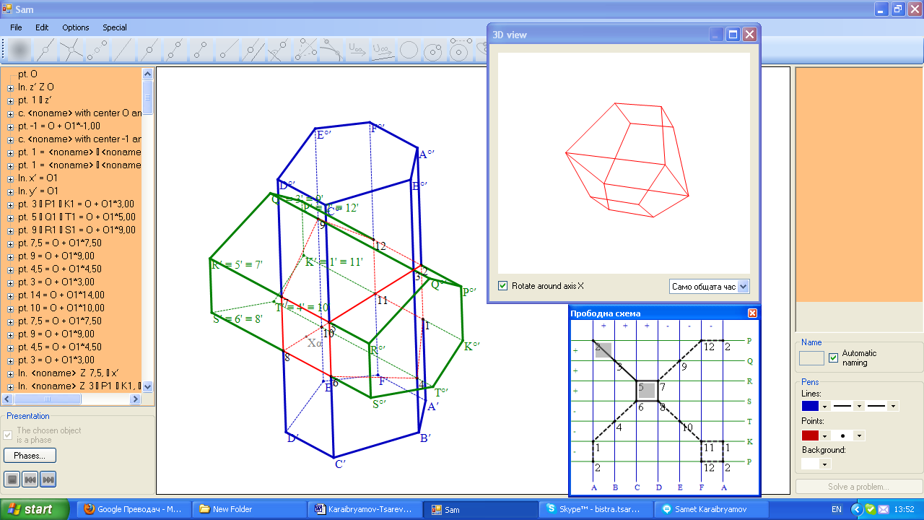
The bases of the prisms lie in coordinate planes µ and ν .The surrounding edges of the prisms are parallel to the axes x and y. Therefore the main axonometric images of the first and of the second traces of the auxiliary planes will be parallel to x' and y', respectively.
Figure 14 Example 4
An interesting moment in the problem is the presence of two tangency areas, because the conditions of the case C6.3 for the surrounding edges AA°, FF°, PP°,
KK° and CC°, DD°, RR°, SS° are fulfilled. The solution is presented in increased orthogonal isometry.

Example 5. Represent the mutual intersection of the right prisms ABCDEFGIJ
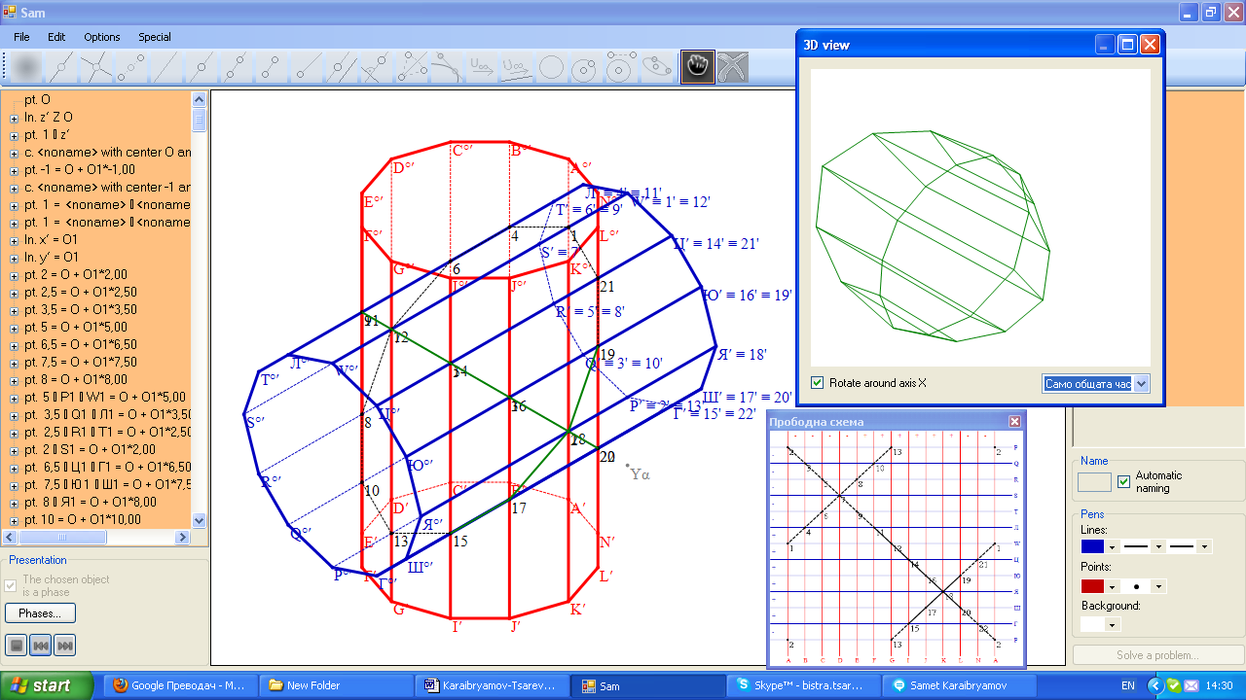
KL A°B°C°D°E°F G° I° J° K° L° [A (2; 5; 0), B (2,5; 3,5; 0), C (3,5; 2,5; 0), D (5; 2; 0), E (6,5; 2,5; 0), F(7,5; 3,5; 0), I(7,5; 6,5; 0), J(6,5; 7,5; 0), K(5, 8, 0), L(3,5, 7,5, 0) A° (2; 5; 10)] and PQRSTKP°Q°R°S°T°K° [P (0; 5; 2), Q (0; 3,5; 3,5), R (0; 2,5; 3,5), S (0;2;5), T (0;
Figure 15 Example 5
2,5; 6,5), Л(0; 3,5; 7,5), W(0, 5, 8), Ц(0; 6,5; 7,5), Ю(0; 7,5, 3,5), Я(0; 8; 5), Ш(0, 7,5; 3,5), Г(0; 6,5; 2,5), P° (10; 5; 2)].
The last example shows as well as the first example a case with two tangency points. But here you can see 3D images of the composition of the two intersecting prisms and also of their common part.

All tasks are composed by our program.

7 Application
We suggest one improvisation on the following task:

Task 1. Represent the mutual intersection of the prism ABCDA°B°C°D° [A(3; 1; 0), B(5; 6,73; 0), C(3,6; 7,8; 0), D(0; 4; 0), A°(2; 5; 14)] and the pyramid VPQRST [V(3; 15; 9), P(5; 0; 1), Q(0; 0; 2), R(1; 0; 7,5), S(7,5; 0; 10,5), T(8,46; 0; 6,4)].

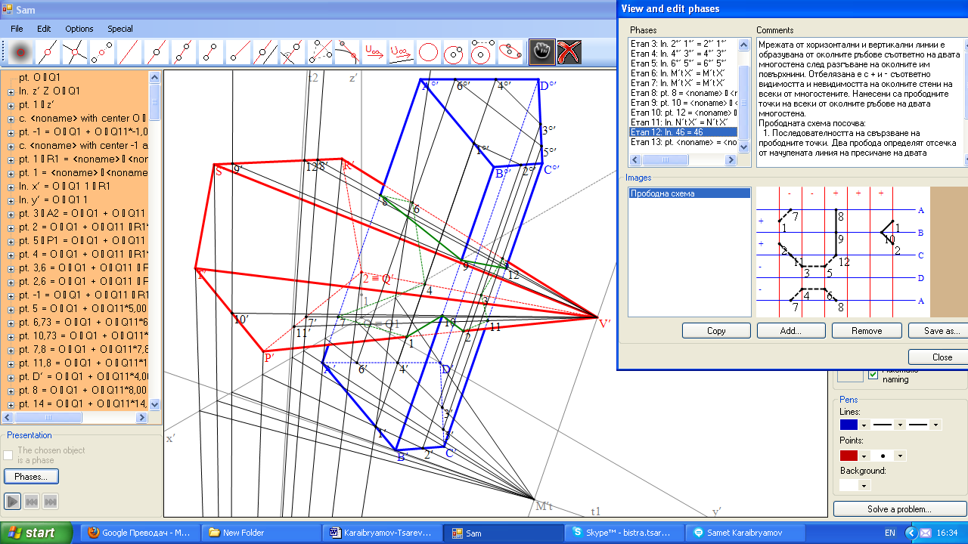
The bases of the prism and the pyramid lie on the coordinate planes µ and ν, respectively. That is why the first and the second traces of the auxiliary planes will appear in the sketch. The surrounding edges DD, VS and VT do not participate in the intersection because their steps are in the isolated parts. There is an isolated part on each polyhedron. That is why in the given task there is one closed space broken intersection line: 1,10,2,11,3,5,12,9,8,6,4,7,1.
Figure 16 Task 1.
The solutions of this task and of the next four ones are presented in increased orthogonal isometry.
We can change the conditions (the coordinates of the verticies) to get another type of intersection. With the help of the program Sam and our classification of the pierce points we composed several tasks, which we present to your attention.

Task 2. Represent the mutual intersection of the prism ABCDA°B°C°D° [A(3,8; 1,2; 0), B(4,4; 4; 0), C(3,2; 5,5; 0), D(1; 3,5; 0), A°(14; 8; 20,5)] and the pyramid VPQRST [V(12; 19; 14), P(3,5; 0; 0,5), Q(0; 0; 2), R(1; 0; 7,5), S(6,5; 0; 10,5), T(8,46; 0; 6,4)].
For starters let's require a penetration of the prism into the pyramid. It means that we have to put two isolated parts on the base of the pyramid. In our choice the surrounding edges VQ, VR and VT of the pyramid will not penetrate the prism.
Let us note that the surrounding edges AA° and VP have a common auxiliary plane. Therefore they intersect in a point 2 (the case C2.1). The
intersection line consists of two closed broken lines.

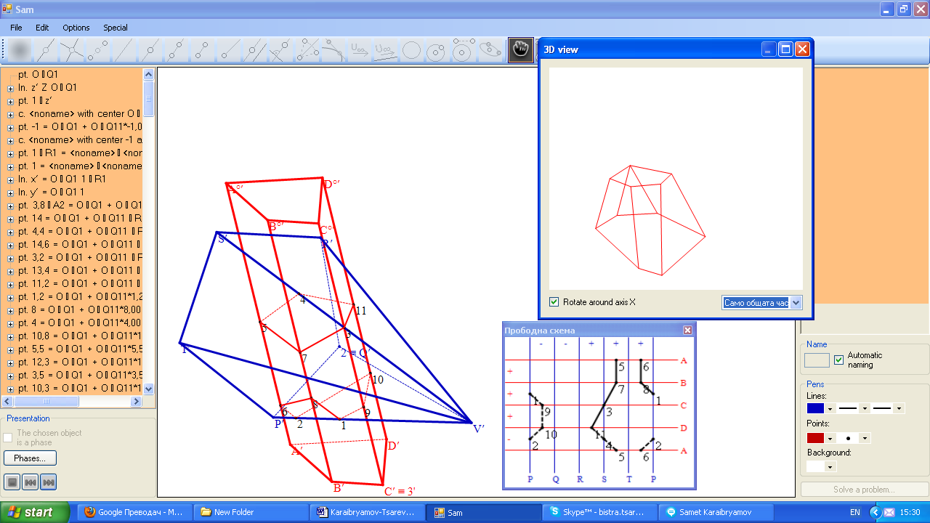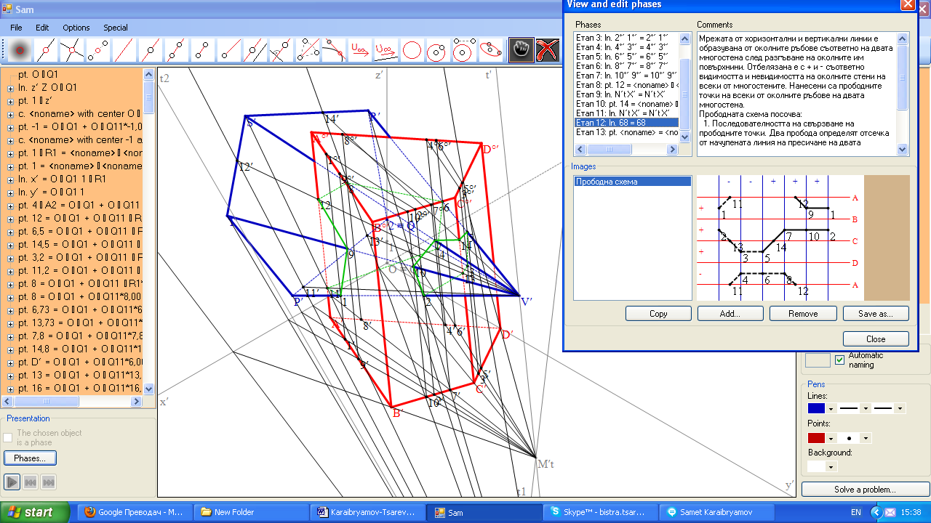
Figure 17 Task 2 Figure 18 Task 3

Task 3. Represent the mutual intersection of the prism ABCDA°B°C°D° [A(4; 1; 0), B(6,5; 6,73; 0), C(3,2; 7,8; 0), D(0; 6; 0), A°(12; 8; 16)] and the pyramid VPQRST [V(12; 19; 14), P(5; 0; 2), Q(0; 0; 2), R(1; 0; 7,5), S(7,5; 0; 10,5), T(8,46; 0; 6,4)].
In this task we reserved the type of intersection, but now we require a penetration of the pyramid into the prism. To achieve this goal it is sufficient to ensure the existence of two
isolated parts on the base of the prism.

Task 4. Represent the mutual intersection of the prism ABCDA°B°C°D° [A(3; 1; 0), B(5,75; 6,73; 0), C(2,8; 6,7; 0), D(0; 2; 0), A°(2; 5; 14)] and the pyramid VPQRST [V(3; 15; 9), P(5; 0; 1), Q(-0,7; 0; 0), R(1; 0; 7,5), S(7; 0; 10,5), T(8,46; 0; 6,4)].
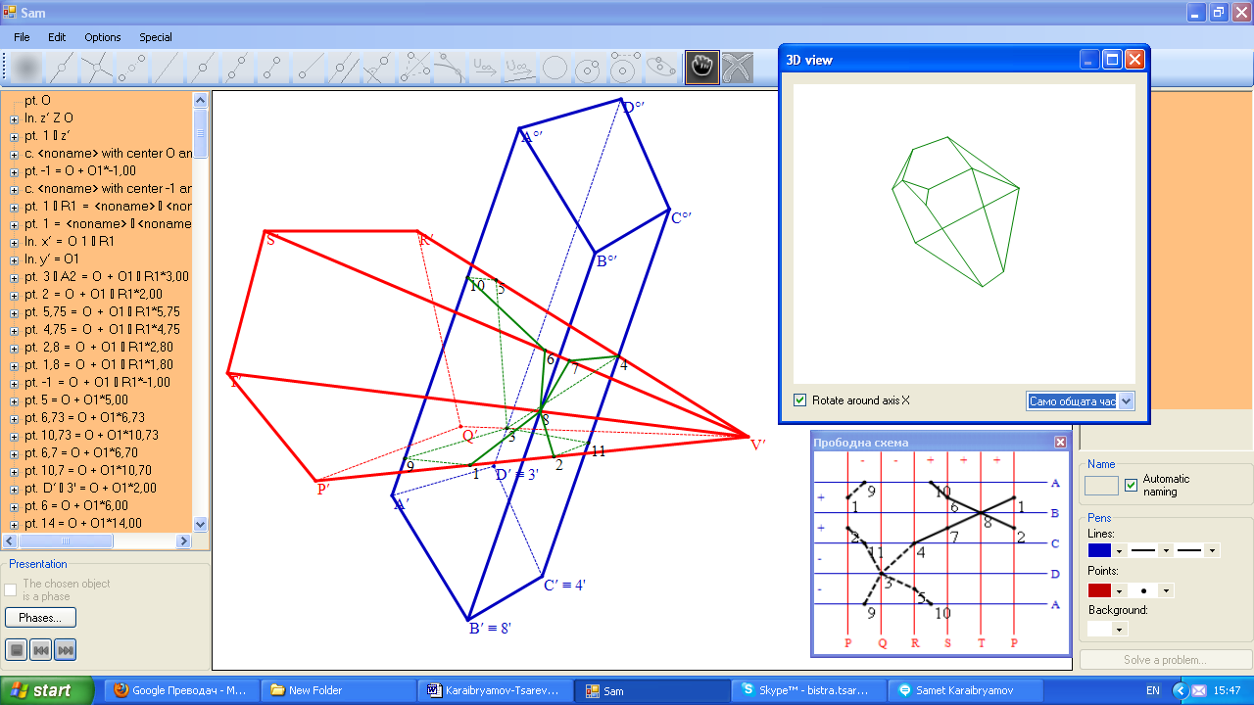
Now we decide to include two tangency points. We have chosen to present the case C4) with the tangency point 8 = BB° ∩ VT and 3 = DD° ∩ VQ. This is achieved by matching of the auxiliary contour planes for the both couples of surrounding edges BB°, VT and DD°, VQ. The intersection line can be described as follows 1,8,7,4,3,9,1 and 2,11,3,5,10,6,8,2.
Figure 19 Task 4

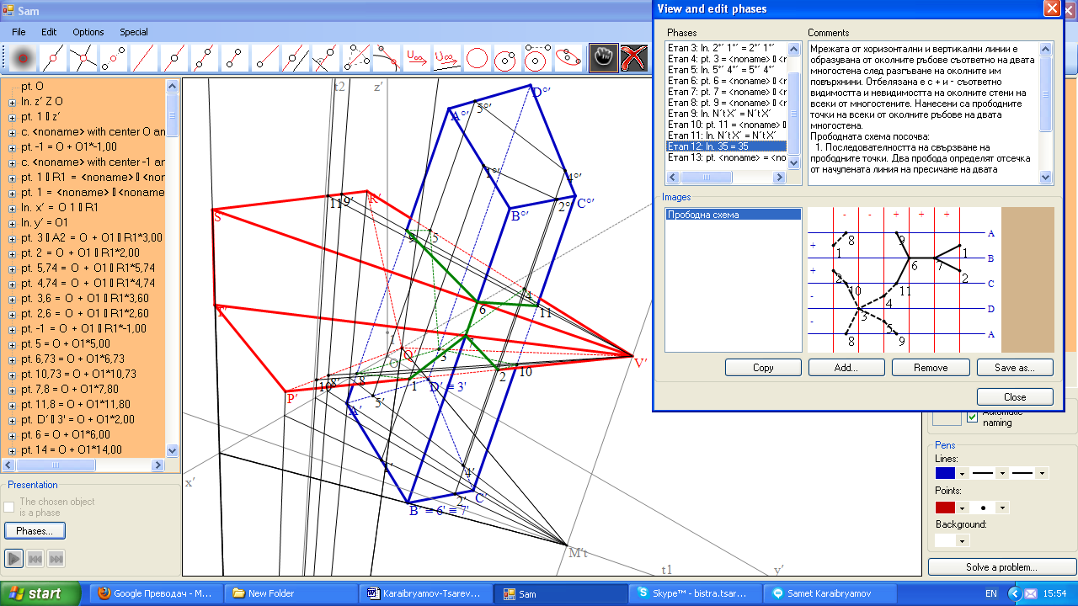
Task 5. Represent the mutual intersection of the prism ABCDA°B°C°D° [A(3; 1; 0), B(5,74; 6,73; 0), C(3,6; 7,8; 0), D(0; 2; 0), A°(2; 5; 14)] and the pyramid VPQRST [V(3; 15; 9), P(5; 0; 1), Q(-0,7; 0; 0), R(1; 0; 7,5), S(8,57; 0; 10,5), T(8,46; 0; 6,4)].
Figure 19 Task 5
In this task we have included one tangency point 3 and a tangency segment 67.
As it is shown in the drawing and in the pierce scheme here it is required the auxiliary planes of the following three surrounding edges: VS, VT and BB° to coincide (the case C5.2.3). The tangency point 3 from the previous task is reserved.

Task 6. Represent the mutual intersection of the prism ABCDA°B°C°D° [A(3; 1; 0), B(5,75;
6,73; 0), C(5,25; 8,12; 0), D(0; 3,3; 0), A°(2; 5; 14)] and the pyramid VPQRST [V(3; 15; 9), P(5; 0; 1), Q(-1,6; 0; 1,8), R(1; 0; 7,5), S(8,58; 0; 10,5), T(8,46; 0; 6,4)].
At the end we propose to be included the tangency area shaped like a trapezium and one tangency point. This happened because: 1) the pairs of neighboring surrounding edges VS, VT and BB°, CC° have a common auxiliary plane; 2) the auxiliary planes of the surrounding edges VQ and DD° are simultaneously tangent and they coincide. The solution is presented in military perspective (Figures 21).and after rotation (Figures 20).

The new approach that we offer in teaching of the mutual intersecting of pyramids and prisms will convert the learning process into a smart and amusing game. It is suitable for distance learning and for specialized secondary schools for building and architecture.
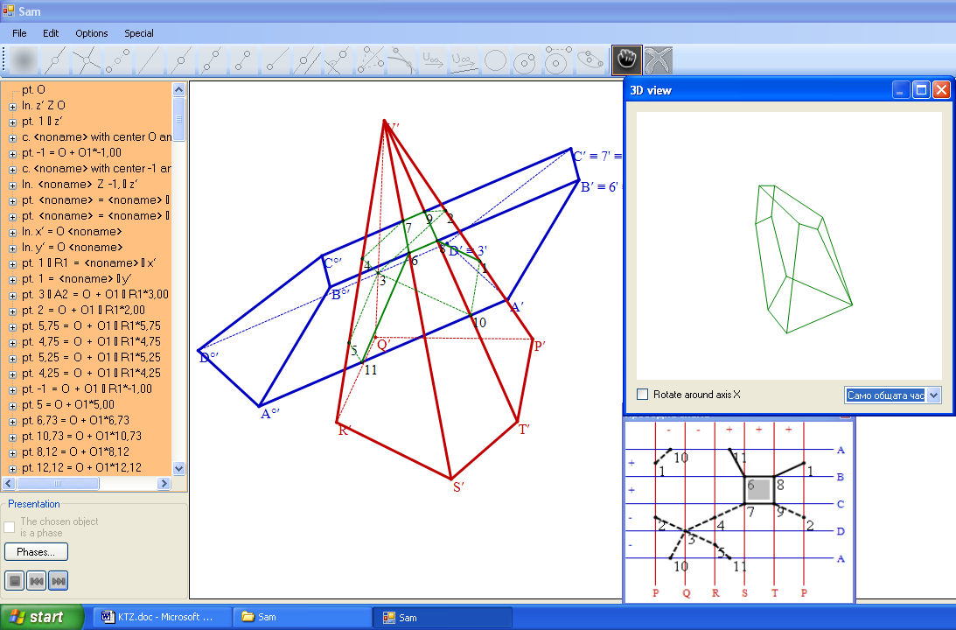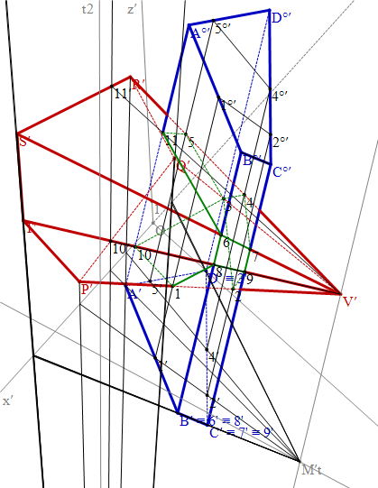
Figure 20 Task 6 Figure 21

8. Conclusion
1. The Educational Software Sam allows to teach and to study the whole variety of tasks on the theme "Mutual intersecting of pyramids and prisms in axonometry” for the shortest time.
2. The presentation of the solution of each problem is a great opportunity for the student to train alone by tracking of each step in the construction of the line of the intersection of two polyhedrons.
3. The software Sam and the classification of the piercing points of the surrounding edges stimulate and facilitate creative activity. Teachers and students can make out easily and quickly not only standard tasks, but can make out tasks with a tangency point, a tangency segment, a tangency area and their combinations, that are missing in the known problem solving books and textbooks.
4. The rotation of perspective images of the composition of the two intersecting polyhedrons, the rotation of their common part and the opportunity for divercity of design decisions in the choice the colours of the lines and background enhance the visual perception of the 3D images.

References
[1] Samet Karaibryamov, Bistra Tsareva, One application of the informatics in the descriptive geometry, REMIA, 2010, Proceedings of the Anniversary International Conference, 10-12 Decembre, 2010, 355-362.
[2] Georgi Petrov, Descriptive Geometry, CI Technique, Sofia, 1960.
[3] Dragomir Chorbadjiev, Descriptive Geometry, Sofia, 2002.
[4] M. C. Hawk, Schaum's Outline of Descriptive Geometry, Schaum's, 1962.
[5] Mark S. Schwendau, Descriptive Geometry: In Pencil and Pixels, Stipes Publishing Company L.L.C., 2009.
[6] J. Sharp, Microsoft Visual C # 2008 Step by Step, 2008, Microsoft Press.
[7] R. Stephens, C # Graphics Programming, 2008, Wiley Publishing.
[8]. Boyan Zlatanov, Samet Karaibryamov, Bistra Tsareva, Textbook (UPSG) on syntetic geometry, http://fmi-plovdiv.org/GetResource?id=980
[9] Ulrich Kovtenkamp, Christian Dohrmann, User Interface Design For Dynamic Geometry Software, Acta Didactica Napocensia, Volume 3, Number 2, 2010, 59-66.
[10] Bistra Tsareva, Interactive training on a syntetic geometry in a dynamic environment, Mathematics and Education in Mathematics, 2012, Proceedings of the Forty First Spring Conference of the Union of Bulgarian Mathematicians, 9-12 April, 2012, Borovets, 401-407.
[11] Boyan Zlatanov, Samet Karaibryamov, Bistra Tsareva, Vertical integration of training in the secondary school and university by projective methods in a dynamic environment, Mathematics plus, 2012, to appear

Authors
Samet Naidov Karaibryamov, einismotic@hotmail.com
Bistra Baeva Tsareva, Faculty of Mathematics and Informatics, University of Plovdiv,
Bulgaria, btsareva@uni-plovdiv.bg
Boyan Georgiev Zlatanov, Faculty of Mathematics and Informatics, University of Plovdiv,
Bulgaria, bobbyz@uni-plovdiv.bg; bzlatanov@gmail.com

